# **Diamond Estimator**

**Objective:**

Estimate the price (in US dollars) for the diamond with characteristics provided by the   
 users. The estimation model is based on linear regression of the available diamonds   
 dataset.

**Output:**

Estimated price & bar graph of the regression coefficients

**Dataset:** diamonds (data.R)

**Variables:**

|  |  |
| --- | --- |
| **Price** (dependent variable) | Price in US dollars |
| Carat | Weight of the diamond |
| Cut | Quality of the cut (Fair is used as the base) |
| Length | Length in mm |

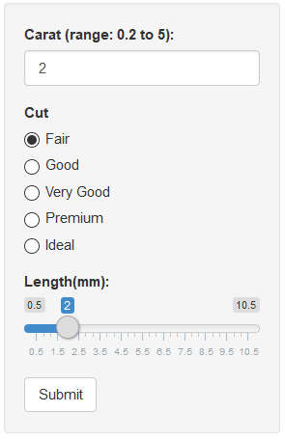

**Steps:**

1. Input the characteristics of the diamond (carat, cut and length)
2. Click “Submit button